

High Level Design
Prepared by: Mark Kelly & Shane Mitchell | 9 September 2025

Exus – Azure Landing Zone



1. Introduction 6
1.1. Summary/Introduction 6
1.2. What is an Azure Landing Zone? 6
1.3. Microsoft’s Cloud Adoption Framework (CAF) 6
1.4. Dependencies 6
1.5. Architecture Design Decisions 7
1.6. Core Components 9
1.7. Azure Platform Architecture 9

2. Azure Landing Zone - Environment Design 11
2.1. Azure Tenant 11
2.2. Azure Region 11
2.3. Resource Organisation 11
2.4. Management Group Design 11
2.5. Subscription Design 13
2.5.1. Subscription Procurement & Billing 14
2.6. Identity and Access Management 14

3. Network Topology 15
3.1. Networking Principles 15
3.2. Connectivity Virtual Network 15
3.2.1. Connectivity Network Subnets 15
3.2.2. Azure VPN Gateway 16
3.2.3. Azure Firewall 18
3.3. Private DNS 18
3.3.1. Azure Private DNS Zones 18
3.3.1. Custom private DNS Zones 19
3.3.2. Azure private DNS Resolvers 19
3.3.3. Private DNS Resolution – Azure to Azure 19
3.3.1. Private DNS Resolution – On-premise to Azure 20
3.3.2. Private DNS Resolution – Azure to On-premise 20
3.4. Public DNS 20
3.5. Security Spoke 21
3.6. Shared Services Spoke Network 21

4. Landing Zone – Security & Governance Design 22
4.1. Microsoft Defender for Cloud 22
4.1.1. Defender Plans 22
4.1.2. Regulatory Compliance 22
4.2. Secrets Management 23
4.3. Encryption at Rest 23
4.4. Encryption in Transit 23
4.4.1. Internet Sourced Traffic 23
4.4.2. PaaS Configuration 23
4.5. Business Continuity 23
4.5.1. Disaster Recovery 23
4.5.1. Platform Backup 23
4.6. Governance 24
4.6.1. Azure Policy 24
4.6.2. Logging 25
4.6.3. Naming Convention 25
4.6.4. Tagging 26
4.6.5. Platform Automation 27

5. Pricing 31

Version Control
Date | Version | Changed By | Reason for Change
25.6.2025 | 0.1 | Mark Kelly | Initial draft
26.6.2025 | 1.0 | Mark Kelly | Updated following peer review

Circulation List
Name | Organisation/Title
Erik Widner | Exus / VP Technical Operations
Nathan Jones | Exus / IT Manager
Avram Enriquez | Exus / Operations Engineer
Shane Mitchell | Version 1 / Cloud Architect
Mark Kelly | Version 1 / Cloud Architect
Priyanka Palankar | Version 1 / DevOps Engineer
Ajay Thomas | Version 1 / DevOps Engineer
Joe Condon | Version 1 / Solution Architect
Anilkumar Thumma | Version 1 / Data Engineer
Lauren Mostyn | Version 1 / Delivery Manager

Reference Documents
Title | Description | Owner

Introduction

Summary/Introduction
In March 2025, leadership teams from Version 1 and Exus met in Pittsburgh to explore a strategic partnership focused on Data and AI. The discussions highlighted Exus’s need for a scalable, unified data platform to overcome fragmented delivery patterns and support future growth. This collaboration aims to modernise Exus’s data infrastructure, improve data quality and governance, and enable more efficient use of AI/ML, reporting, and analytics capabilities.
This document outlines the high-level design of the Azure Landing Zone for Exus. The Landing Zone provides the foundational architecture for securely hosting workloads in Microsoft Azure, aligned with the Microsoft Cloud Adoption Framework best practices. It establishes a scalable, governed environment with guardrails for identity, security, networking, and resource organisation. The first workload to be onboarded is the Enterprise Data Platform (EDP), which Version 1 is currently designing to address Exus’s data fragmentation, scalability challenges, and governance needs.
The Azure Landing Zone is designed not only to support the EDP but also to enable the seamless onboarding of future workloads. It provides a flexible foundation that will allow Exus to scale its cloud operations, adopt new services, and respond to evolving business needs with agility. By establishing clear governance, security, and operational standards from the outset, the Landing Zone ensures that future deployments are consistent, secure, and aligned with best practices positioning Exus for long-term success in Azure.

What is an Azure Landing Zone?
The Azure Landing Zone solution is a framework that helps organisations set up a secure, multi management group, multi subscription environment based on Azure best practices. The solution ensures that sufficient guardrails and guidelines are implemented as your organisation prepares to migrate and build workloads on Azure. The purpose of the Landing Zone solution is to provision the foundational Azure services and components that will provide Exus with a stable starting point for transitioning workloads in a safe, secure and predictable manner.

Microsoft’s Cloud Adoption Framework (CAF)
The Microsoft Cloud Adoption Framework (CAF) for Azure is a full lifecycle framework that enables cloud architects, IT professionals, and business decision makers to achieve their cloud adoption goals. It provides best practices, documentation, and tools that help create and implement business and technology strategies for the cloud.
As per the CAF model, the Azure Landing Zone design is categorised into two primary design areas: Environment design and Compliance design. Each of these design areas has a number of sub-sections which describe various principles that need to be considered before implementing the Landing Zone. These design areas are described in further detail in the following sections.

Dependencies

When navigating this document, please refer to the hand icon placed throughout. This icon indicates a specific task for Exus to address in order to complete the solution or an open design decision which requires further input from Exus. These pending tasks and decisions need to be closed before the solution can be marked as complete.

Architecture Design Decisions
For ease of reference, all key design decisions have been consolidated into the table below. This provides a single, high-level overview of the most critical elements of this design.
ID | Design Area | Design Decision
1 | Azure Subscriptions | Three Subscriptions will be deployed to support the Landing zone.
2 | Azure Subscriptions | All Azure Subscriptions required to support the Landing Zone will be procured via Version 1’s Software Asset Management (SAM) team.
3 | Azure Access | The Version 1 project team has been provisioned with guest accounts in the Exus’ Microsoft Entra ID tenant to facilitate access to Azure for this engagement.
4 | Network Topology | A centralised Hub Virtual Network will be deployed within the Connectivity Subscription to facilitate a Hub & Spoke Network topology. Azure Firewall we be deployed in the Hub to handle traffic flows.
5 | Network Topology | Each Subscription will be deployed with a dedicated Spoke Virtual Network to provide a level of network isolation between workloads and applications.
6 | Network Topology | Direct connectivity between each Spoke Virtual Network will not be configured. Rather, each Spoke Virtual Network will be peered to the Hub Virtual Network. Connectivity between Spoke Virtual Networks requires an appropriate Firewall policy to permit such flows.
7 | Network Topology | Network traffic between services hosted in the same Virtual Network does not need to traverse the firewall appliance hosted in the Hub Virtual Network.
8 | Networking - Egress Design | All spoke subnet route tables will be configured with a default route (0.0.0.0/0) with a next hop mapped to the Azure Firewall private IP hosted within the Hub network. Egress connectivity to the Internet is dependent on an appropriate firewall policy. Internet egress will be denied by default and permitted granularly only as required.
9 | Networking – Ingress Design | No requirement for ingress traffic from the internet has been identified. Therefore, there will be no inbound public endpoints deployed as part of the Landing Zone.
10 | Network Connectivity - Private | Privtae connectivity to Exus HQ in Pittsburgh will be established using a site-to-site VPN.
11 | Private Endpoints | To improve the security posture of the Landing Zone, all PaaS services will be configured with private endpoints to ensure traffic between PaaS services hosted in the same Virtual Network remains local to the network
12 | Private DNS | Private DNS zones will be deployed to the Connectivity Subscription to centralise name resolution for workloads and applications hosted in the Landing Zone. No private DNS zones will be deployed to any other Subscription. Name resolution will be satisfied by way of VNet peering between the private hosted zones and each Spoke Virtual Networks.  The chosen zone for Azure is:  internal.exus.us
14 | Private DNS Resolution | Inbound endpoints will be deployed to the Connectivity Virtual Network to provide an IP address to forward DNS queries from on-premises and Azure virtual networks. All Private DNS zones that are linked to the Connectivity virtual network are resolved by the inbound endpoint.  There is no requirement for Azure service to revolve DNS hosted on-premise.
15 | Public DNS | No public DNS zones are required.
16 | Naming Convention | The naming convention to be adopted for all Azure services relating to the management of the solution is: <sub>-<env>-<region>-<service>-<##>
17 | Naming Convention | The naming convention to be adopted for all Azure services deployed to support a specific application is: <app>-<env>-<region>-<service>-<##>
18 | Azure Governance | Azure Policy will be used to enforce best practices and guardrails. We will primarily deploy policies with a Deny effect to prevent the creation of non-compliant resources. Policies with an Audit effect will only be used by exception, and where a suitable "Deny" policy does not exist.
19 | Azure Security | A dedicated Security Subscription will be deployed. This Subscription will host Defender for Cloud and used to assess the security posture of the Landing Zone from a Platform perspective. This subscription will also host a Log Analytics workspace to aggregate Platform level Activity logs across the Landing Zone.
20 | IAM | All Entra ID identities will be created by Exus including guest accounts, member accounts and Service Principal accounts.
21 | Platform Automation | All Azure services to support the Landing Zone will be deployed via Terraform, HashiCorp’s Infrastructure a Code tool.
22 | Platform Automation | All Infrastructure as Code will be version controlled under Exus’ Azure DevOps Organisation. CI/CD pipelines will leverage Azure DevOps pipelines to manage infrastructure changes.
23 | Platform Automation | A Service Principal will be generated under Entra ID and leveraged by the Azure DevOps pipelines to automate the deployment of Azure services. The Service Principal will be configured with an Owner role across all Subscriptions.
24 | Availability | Azure PaaS services will be configured within a single Availability Zone, except where the service supports a Production workload.
25 | DR | Services will be deployed in a single Azure Region; no Disaster Recovery environment will be deployed.
26 | Regionality | The Azure Landing Zone will be deployed within a single Azure Region. The chosen region is East US.
27 | Monitoring | Azure native monitoring services will be leveraged to monitor the health of services deployed as part of the Landing Zone e.g. Azure Firewall.
28 | Cost Management | A cost management dashboard will be created for each Subscription and hosted under the Security Subscription to provide a level of financial observability across the entire estate.

Core Components
Service | Description
Organisation Structure | Multiple management groups and subscriptions are deployed to isolate workloads and environments
Hub & Spoke Topology | A Hub and Spoke network topology is deployed to facilitate a centralised egress traffic pattern
Firewall Capability | A firewall capability is deployed to route various traffic flows across the Azure estate
Centralised Logging | A centralised Azure Log Analytics workspace collates and aggregates platform logs
Secrets Management | A subscription specific Key Vault instance is deployed to provide a secure secret, password, and certificate store
Policy Compliance | Azure Policy is leveraged to enforce organisational and regulatory compliance standards
Platform Automation | The configuration of Landing Zone resources are managed by an Infrastructure as Code tool (Terraform), version controlled using Azure DevOps Repositories and deployed using Azure DevOps Pipelines
Monitoring | Azure Monitor is used to provide visibility over resource health
Security | Defender for Cloud is configured across all subscriptions, where appropriate, to provide deep insight into the security posture of the platform

Azure Platform Architecture
The diagram below illustrates a high-level overview of the Azure Landing Zone solution and the in-scope Azure Subscriptions: Connectivity, Shared Services and Security.
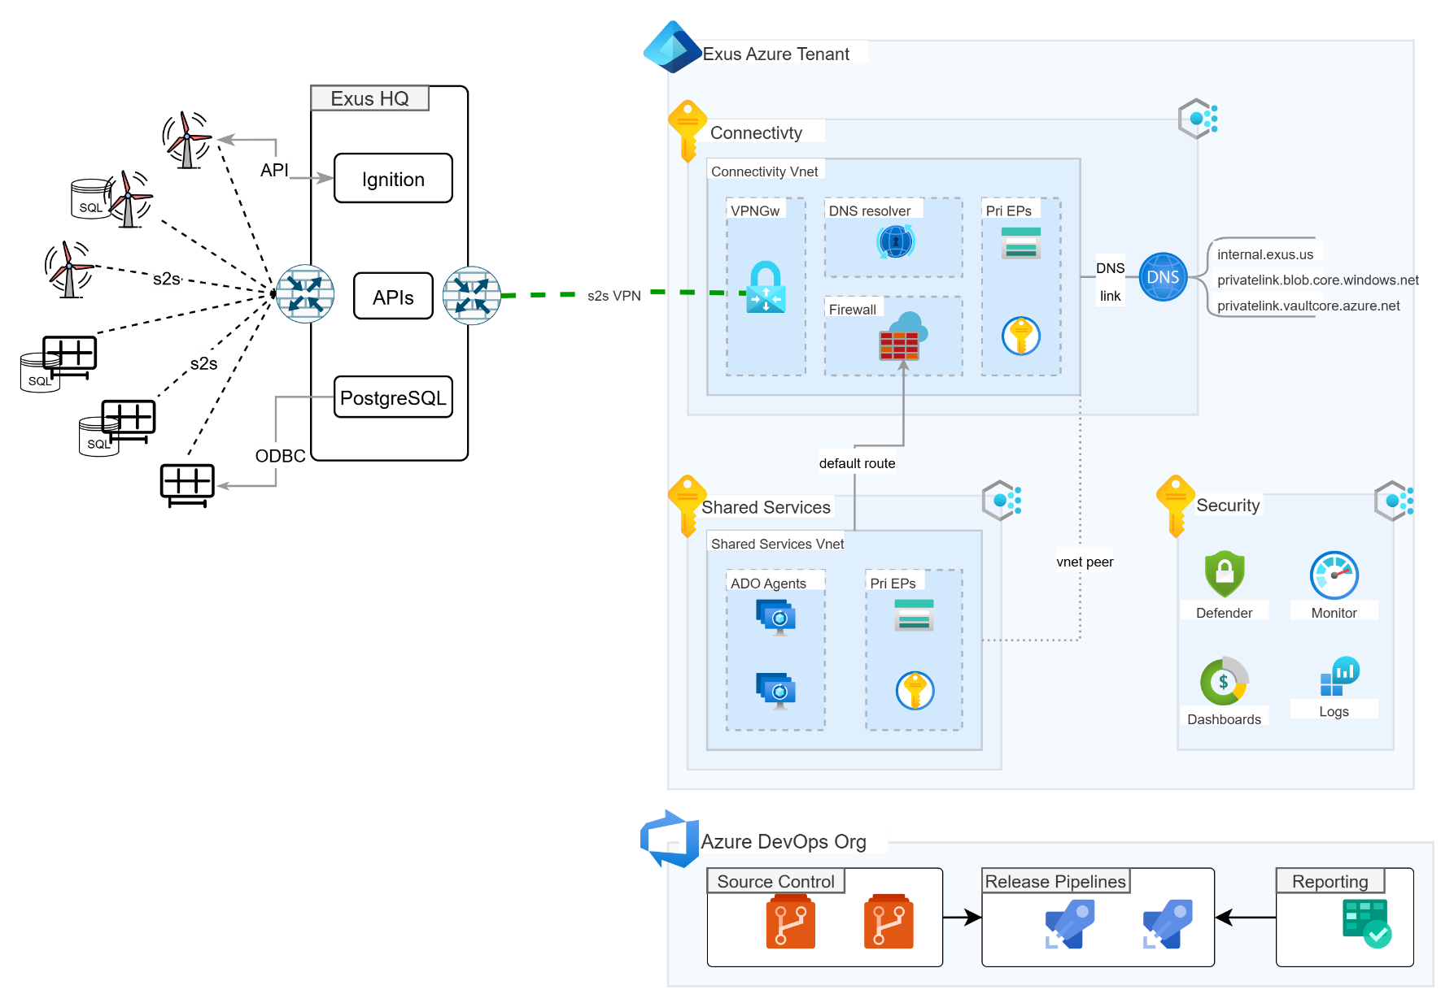
Figure 1 Azure Landing Zone: Platform Architecture

Azure Landing Zone - Environment Design

Azure Tenant
The table below details the most pertinent details of the Exus’ Azure tenant.
Azure Tenant Name | Primary Domain | Tenant ID
Exus Renewables North America | exus.us | aa9cf2a0-7168-45f8-a410-8c0da86c7baa

Azure Region
The Landing Zone solution will be deployed to Azure’s U.S. East region only.

Resource Organisation
Azure provides four hierarchical levels of management scope: Management Groups, Subscriptions, Resource Groups and Resources.
- Management Groups: These groups are containers that help you manage access, policy, and compliance for multiple subscriptions. All subscriptions in a management group automatically inherit the conditions applied to the management group.
- Subscriptions: A subscription logically associates user accounts and the resources that were created by those user accounts. Each subscription has limits or quotas on the amount of resources you can create and use. Organisations can use subscriptions to manage costs and the resources that are created by users, teams or projects.
- Resource Groups: A resource group is a logical container into which Azure resources like virtual machines, virtual networks and storage accounts are deployed and managed.
- Resources: Resources are instances of services that you create such as virtual machines, storage or SQL databases.

Management Group Design
To align with Microsoft’s Cloud Adoption Framework (CAF) best practice, a new root level Management Group (MG) will be created which falls directly under the default ‘Tenant Root Group’, a Management Group that is generated automatically when procuring an Azure Tenant. This new Management Group will host 2 child Management Groups: a Platform MG and a Landing Zones MG.
This approach provides a clear delineation between Exus’ core cloud platform services e.g. networking, management and security services, and application-level services e.g. EDP.
The table below captures the Management Groups that will be as part of the Landing Zone implementation and their role.

Mgmt. Grp | Hierarchy | Description
Tenant Root Group | 1 | Each directory is assigned a single top-level management group called the Tenant Root Group. This root management group is built into the hierarchy to have all management groups and subscriptions fold up to it. This root management group allows for global policies and Azure role assignments to be applied at the directory level.
Exus-MG | 2 | The Exus-MG Management Group is the Exus managed root Management Group, created to align with best practice.
Platform-MG | 3 | The Platform-MG Management Group is created to centrally host all core landing zone services e.g. The Connectivity/Hub services, security and management services etc.
Landing-zones-MG | 3 | The Landing-zones-MG is created to host all application specific Management Groups. For example, this is where the services to support the Enterprise Data Platform will be hosted. Similarly, this is where all new applications developed in the future should be hosted.
Connectivity-MG | 4 | The Connectivity Management Group hosts the Connectivity Subscription only.
Management-MG | 4 | The purpose of this Management Group is to host workloads and services that are common to the wider Landing Zone. At the time of writing, this Management Group will host a Shared Services Subscription only.

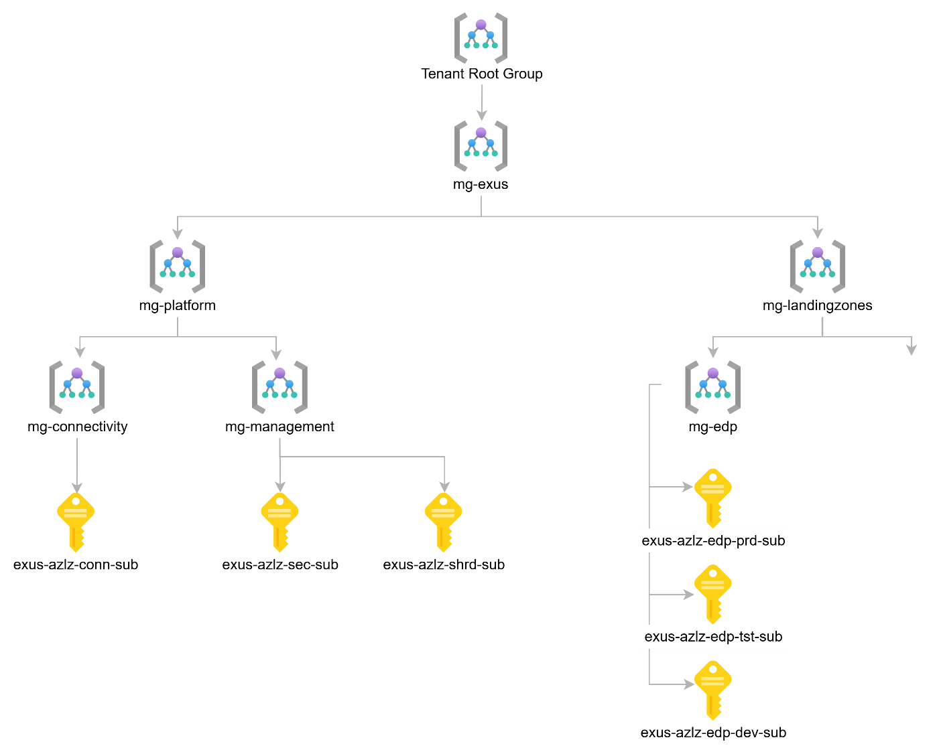

Figure 2 Azure Management Group Hierarchy

Subscription Design
To provide a greater level of control and governance over workloads, the Landing Zone solution prescribes the deployment of multiple Azure subscriptions where each subscription maps to a particular workload. This multi-subscription structure provides a more secure level of isolation between workloads and their environments.
The table below captures the Azure Subscriptions that will be deployed.
Subscription | Type | Subscription Name | Purpose
Connectivity | Management | exus-azlz-conn-sub | Serves as the central networking hub for the entire Azure LZ. It hosts critical networking services, including Azure Firewall for centralised egress, VPN gateways for terminating s2s VPN connections from on-premises networks or remote sites. Acts as a secure transit network, connecting all workload subscriptions and external networks.
Security | Management | exus-azlz-sec-sub | Centralises security management, including a shared Log Analytics workspace for aggregating logs and, if required, Microsoft Sentinel for platform-level threat detection and incident response.
Shared Services | Management | exus-azlz-shrd-sub | Contains foundational services and tools that are used by all workloads across all environments e.g. Azure DevOps private agents, monitoring agents etc.

Subscription Procurement & Billing
Version 1 is confirmed as Exus’ Microsoft Cloud Solution Provider (CSP) partner. We will be responsible for procuring all new Azure subscriptions on behalf of Exus. This new relationship streamlines the management and billing process, as we will directly provision subscriptions under our CSP agreement. This provides Exus with a single point of contact for Azure services and ensures that all subscriptions are aligned with the security and governance standards we will implement within the landing zone.
Going forward, when a new subscription is required, our team will manage its creation, and it will appear in your Azure Active Directory tenant under our management. This model ensures consistency, simplifies the procurement process, and gives us full control to apply the necessary policies and guardrails from the moment a new subscription is created.

Identity and Access Management
When onboarding new team members or 3rd party suppliers to the Azure Landing Zone, Exus will be responsible for generating the required identity under Entra ID (either by way of an invite if the resource is already aligned with another directory or by creating a new member account identity) and assigning the requisite roles for each.
The Version 1 project team has been provisioned with guest accounts in the Exus’ Microsoft Entra ID tenant to facilitate access for this engagement.

Network Topology
An integral component of an Azure Landing Zone is the hub and spoke network topology that will facilitate and govern the flow of traffic to/from, as well as within, the Azure environment. The Hub network provides a centralised point for managing ingress and egress for both North/South and East/West traffic profiles, and by implication provide a centralised point to administer security policies, filtering and inspection against such traffic.
Connected to the Hub, using Vnet Peering, are Spoke Virtual Networks. A Spoke Virtual Network is an IP address space where individual workloads can be deployed in an isolated manner, providing a security boundary between these resources and resources in other networks.

Networking Principles
The following networking principles will be adopted as part of the Landing Zone build.
- All Spoke to Spoke Virtual Network traffic must traverse the Azure Firewall appliance hosted in the Connectivity Virtual Network.
- Network traffic between services hosted in the same Virtual Network does not need to traverse the firewall appliance hosted in the Hub Virtual Network.

- A route table will be assigned to each subnet to establish a one-to-one relationship.
- All Spoke Route Tables will be configured with a default route (0.0.0.0/0) pointing to the Azure Firewall service hosted in the Connectivity Virtual Network. Doing so forces traffic egressing the Azure Landing Zone’s Spoke Virtual Networks to traverse the Azure Firewall service and therefore this traffic will be subject to the policies and controls configured there.

- All Azure PaaS services will be configured with private endpoints to ensure traffic between PaaS services hosted in the same Virtual Network remains local to the network.
- All private DNS zones will be centralised to the Connectivity Subscription and linked to the Connectivity Virtual Network only.

Connectivity Virtual Network
As part of the Landing Zone solution, a dedicated Connectivity Subscription will be deployed to host the Hub Virtual Network within the US East region. This Virtual Network will be peered with all Spoke Virtual networks to facilitate East/West and North/South traffic flows, as required.
The table below captures the name and network address of the Hub Virtual Network hosted within the Connectivity Subscription.
Subscription | Virtual Network | Network Address
exus-azlz-conn-sub | ex-conn-prd-eus-vnet-01 | 10.200.0.0/23

Connectivity Network Subnets
The table below details the subnet breakdown for the Connectivity Virtual Network. Please note, a number of subnets have been reserved for future expansion e.g. if an Expressroute is required, if an Application Gateway (HTTPS Load Balancer) is required for exposing public services/APIs etc.

Subnet | Network | Purpose
AzureFirewallSubnet | 10.200.0.0/26 | Hosts the Azure Firewall service for centralising egress traffic from the Landing Zone.
GatewaySubnet | 10.200.0.64/27 | Hosts a Virtual Network Gateway for establishing VPN tunnels between the Azure Landing Zone and other sites e.g. Exus’ Pittsburgh site.
pdns-snet | 10.200.0.96/27 | Hosts the Azure private DNS Resolver service to facilitate inbound name resolution for on-premise services resolving Azure hosted services.
pe-snet | 10.200.0.128/27 | A dedicated subnet to host private endpoints for PaaS services deployed to the Connectivity subscription e.g. Key Vault, Storage Account.
Reserved | 10.200.0.160/27 | Reserved
Reserved | 10.200.0.192/26 | Reserved
Reserved | 10.200.1.0/24 | Reserved

Azure VPN Gateway
Azure VPN Gateway service is an Azure managed service used to establish encrypted connectivity (IPSec VPN tunnels) between an Azure virtual network and on-premises locations over the public Internet. While the service can also be leveraged to establish encrypted connections between Azure virtual networks over the Microsoft network, it will not be used for this purpose.
A single VPN Gateway can be configured to establish multiple encrypted connections to various sites. However, when doing so, all VPN tunnels share the available gateway bandwidth.
A VPN Gateway deployed to a dedicated subnet in the Connectivity virtual network will be used to establish a site-to-site VPN tunnel between the Azure Landing Zone and Exus’ on-premise Pittsburgh/HQ site.

Gateway Name | SKU | S2S Tunnels | Throughput Benchmark
ex-conn-prd-eus-vpngw-01 | VpnGw2AZ | Max. 30 | 1.25 Gbps

VPN Gateway Maintenance
Every Azure VPN gateway consists of two instances in an active-standby configuration by default. For any planned maintenance or unplanned disruption that happens to the active instance, the standby instance takes over automatically (failover), and resumes the S2S VPN or VNet-to-VNet connections.

High Availability

While we have the ability to configure an active-active VPN connection, since there is a only a single Cisco appliance on-premise with which to terminate connections and since the throughput requirements are not fully understood yet, we will deploy a single connection only. This connectivity approach is best illustrated in the diagram below.

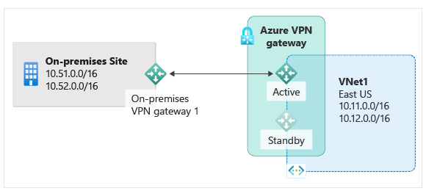
Figure 3- VPN Gateway High Availability
However, we can at a later point, decide to configure an active-active highly available connection to increase the resiliency of this critical infrastructure.

Site-to-Site VPN
The table below captures the Pittsburgh HQ Firewall appliance and local network details which need to be accessible from over the Site-to-Site IPSec VPN.
Pittsburgh HQ Site Details
Appliance | Cisco Meraki
Name | WAN 1
Public IP | 199.219.234.86
Status | Active
Encryption Domains | Data: 192.168.200.0/24  AnyConnect VPN: 10.254.254.0/24
Preshared Key | Exchanged over private session
Routing Method | Static
Routing Type | Policy Based

The table below captures the Azure VPN Gateway and Landing Zone network details which need to be accessible from over the Site-to-Site IPSec VPN.

Azure Landing Zone
Appliance | VPN Gateway
Name | ex-conn-prd-eus-netw-rg-01
Public IP | 13.82.9.28
Status | Active
Encryption Domains | 10.200.0.0/20
Preshared Key | Exchanged over private session
Routing Method | Static
Routing Type | Route Based

Azure Firewall
Azure Firewall is an Azure native Firewall as a Service that provides much of the same functionality as a Next Generation Firewall (NGFW) e.g. FortiGate, Palo Alto etc. The service provides two tiers: Standard and Premium. The Premium tier will be deployed to the Connectivity subscription. A non-exhaustive list of the services available under the Premium tier includes are captured below:
- TLS inspection - decrypts outbound traffic, processes the data, then encrypts the data and sends it to the destination.
- IDPS - A network intrusion detection and prevention system (IDPS) allows you to monitor network activities for malicious activity, log information about this activity, report it, and optionally attempt to block it.
- URL filtering - extends Azure Firewall’s FQDN filtering capability to consider an entire URL along with any additional path. For example, www.contoso.com/a/c instead of www.contoso.com.
- Web categories - administrators can allow or deny user access to website categories such as gambling websites, social media websites, and others.
- PCI Compliant - The Premium SKU complies with Payment Card Industry Data Security Standard (PCI DSS) environment needs.

A single Azure Firewall instance will be responsible for filtering all Azure sourced traffic, regardless of environment, to other Azure networks (deployed as part of the Landing Zone), on-premise environments or the Internet. By default, a blanket deny-all policy will be configured which will force the creation of explicit policies to permit such traffic flows.

Private DNS

Azure Private DNS Zones
As per the Design Decisions table, to improve the security posture of the Landing Zone, all Azure PaaS services will be configured with private endpoints to ensure traffic between it and other services hosted in the same Virtual Network remains local to the network and not traverse the public internet. A private hosted zone is required for each PaaS service to facilitate this. Some examples of these hosted zones are listed below.
Azure Service | Private Hosted Zone Name
Blob Service | privatelink.blob.core.windows.net
Key Vault | privatelink.vaultcore.azure.net
Azure DataBricks | privatelink.azuredatabricks.net

All private hosted zones will be created under the Connectivity Subscription and linked to the Connectivity Virtual Network. This approach introduces a centralised pattern to reduce the sprawl of private hosted zones across the Landing Zone.

Custom private DNS Zones
To simplify access for end-users (Exus users accessing Azure hosted environments from their local workstations over VPN), we'll introduce a custom Azure Private DNS Zone. This addresses the complexity of default PaaS service URLs, which are often long, machine-generated, and not human-friendly e.g. dev.databricks34122142.privatelink.databricks.com.
By creating a custom zone, we will establish user-friendly CNAME records which map to the private endpoint's canonical name. This approach abstracts away the complex underlying URLs, allowing users to access services with simple, memorable names, thereby reducing friction and potential for error while ensuring all traffic remains secure over the private network.


The proposed custom domain name that will be created within he Connectivity Subscription is detailed below.
Azure Service | Custom Name
Private DNS Hosted Zone | internal.exus.us

Azure private DNS Resolvers
Azure DNS Private Resolver is a fully managed, highly available service that enables secure DNS resolution between Azure virtual networks and on-premises environments without the need to deploy, manage, or patch custom DNS servers.
Inbound endpoints will be deployed to the Connectivity Virtual Network to provide an IP address to forward DNS queries from on-premises and Azure virtual networks. All Private DNS zones that are linked to the Connectivity virtual network are resolved by the inbound endpoint.

Private DNS Resolution – Azure to Azure
The Azure Firewall service, hosted within the Connectivity Virtual Network, will be configured to act as a DNS proxy. A DNS proxy is an intermediary for DNS requests from client virtual machines or PaaS services to a DNS server. To enable this, the DNS settings for all Spoke Virtual Networks will be configured to point to the Azure Firewall private IP.
The DNS proxy endpoint (Azure Firewall private IP) listens for DNS queries, originating from within the Landing Zone, on port 53 and forwards all queries to Azure’s private DNS resolver endpoint IP – the IP will not be known until after deployment.
This approach allows us to leverage Azure Firewall’s security policies by enabling FQDN (Fully Qualified Domain Name) filtering and threat intelligence against DNS queries. For example, because the firewall is the first to resolve the domain name, it can apply rules based on the FQDN instead of just the destination IP address.

Private DNS Resolution – On-premise to Azure

As discussed during a Discovery workshop in September 2025, since Exus do not manage an on-premise DNS server, there is a dependency on their IT team to create a DNS forwarding rule on their Cisco Meraki appliance hosted within their HQ (on-premise) site at Pittsburgh. This rule will forward all Azure DNS queries initiated from on-premise (from Virtual Machines or laptops connected over VPN to the on-premise site) to the Azure private DNS resolver inbound IP.

This DNS setup is best illustrated in the diagram below.
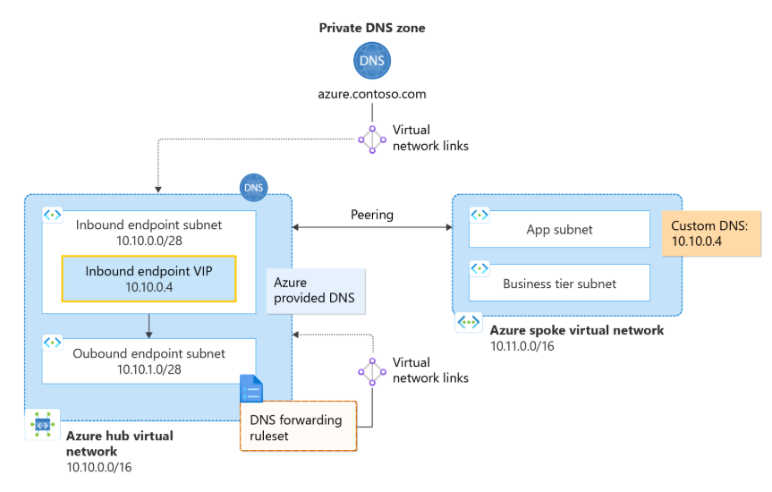
Figure 4- Private DNS Resolution

Private DNS Resolution – Azure to On-premise
At this point there is no requirement for Azure hosted services to resolve on-premise hosted services or applications.

Public DNS
At this point there is no requirement to establish any public DNS zones within Azure.

Security Spoke
While several services will be deployed to the Security Subscription to provide a centralised control plane over the Landing Zone’s security and management e.g. Defender for Cloud, we don’t have an immediate requirement for a Virtual Network currently. However, to account for future requirements we have ring fenced a network range, detailed below.
Subscription | Virtual Network | Network Address
exus-azlz-sec-sub | ex-conn-prd-eus-vnet-01 | 10.200.2.0/24

Shared Services Spoke Network
A Virtual Network will be deployed to the Shared Services Subscription to facilitate private connectivity to shared services which will be leveraged by the Landing Zone and in future to support the deployment of the Enterprise Data Platform and future applications as required.
This Virtual Network will be peered to the Connectivity Virtual Network to facilitate communication between services hosted here and elsewhere in the Landing Zone.
Subscription | Virtual Network | Network Address
exus-azlz-shrd-sub | ex-conn-prd-eus-vnet-01 | 10.200.3.0/24

At the time of writing, the only service that will be hosted within the Shared Services Virtual Network is a Virtual Machine Scale Set to support private Azure DevOps agents.

Landing Zone – Security & Governance Design
Security is a core consideration for the Landing Zone solution. Whilst designing and implementing the Azure Landing Zone, security will be considered and addressed throughout the process. The following sub-sections address the key security considerations.

Microsoft Defender for Cloud
Defender for Cloud is a Cloud Security Posture Management (CSPM) service that continually scans and provides recommendations for security hardening by generating a Secure Score value.
Defender for Cloud will be enabled against all Azure Subscriptions. However, visibility of the service will be restricted to key personnel only and changes to the service’s configuration will be managed from the Security Subscription only.
Enabling the service willl provide Exus with a baseline security metric with which to measure the overall security posture of the platform.

Defender Plans
Defender for Cloud provides foundational cloud security and posture management (CSPM) features by default. However, there are a number of enhanced security features which are available through “add-on” Defender Plans.
To provide an extra level of protection against potential threats and to help identify vulnerabilities early, the Azure services hosted in each subscription should be evaluated before enabling the most appropriate Defender Plans.
The table below captures the Defnder Plans that will be enabled as part of the Landing Zone.
Defender Plan | Description
Defender for Storage |  | Defender for Storage proactively detects and alerts on unusual and potentially malicious activities, such as suspicious access patterns, unusual data exfiltration, and the uploading of malware.
Defender for Key Vault |  | Defender for Key Vault provides threat protection by monitoring for suspicious access and usage patterns of secrets, keys, and certificates. Together, these plans offer intelligent, behavior-based threat detection and response, ensuring that critical data and cryptographic assets are continuously protected beyond standard access controls and network configurations.

The cost model for Defender Plans is based on consumption and as such Exus will only be invoiced for the Azure services leveraging the Defender Plan. For example, if the Key Vault Defender Plan is enabled but no Key Vaults exist within the subscription, Exus will not be charged for this.

Regulatory Compliance
Azure’s Defender for Cloud service includes a regulatory compliance dashboard which measures your Azure estate against specific regulatory compliance standards. This dashboard provides insights into your organisation’s compliance posture allowing Solution Architects, Security Architects, and Engineers to assess how compliant your Azure resources and configurations are when measured against specific compliance standards.
In the absence of a specific regulatory compliance mandate, the CIS standard provides an industry-recognised benchmark for baselining and assessing the security posture of the Landing Zone. The Azure CIS framework will be deployed across all Azure Subscriptions.

Secrets Management
As part of the Landing Zone solution, Azure’s Key Vault service will be leveraged to host sensitive data including secrets and certificates.
A dedicated Azure Key Vault instance will be deployed per Azure Subscription. This approach provides a level of logical isolation for secrets management across subscriptions, reducing the potential for cross contamination and facilitating a least privilege RBAC model.

Encryption at Rest
All Azure PaaS services deployed as part of the Landing Zone will leverage Azure’s default, platform-managed keys to encrypt data at rest. This approach ensures that all data is automatically protected with a robust encryption mechanism without introducing additional operational overhead. The use of customer-managed keys will not be implemented, thereby simplifying the cryptographic key lifecycle management and allowing the solution to rely on Azure’s built-in security and operational efficiencies for data protection.

Encryption in Transit

Internet Sourced Traffic
This Landing Zone design has not considered the approach for exposing public facing services e.g. web services. Based on multiple workshops with Exus, we acknowledge that there is no short-term requirement for surfacing applications publicly e.g. by way of a HTTPS Load Balancer.
The ingress design for applications requiring publicly accessible endpoints should be considered on a case-by-case basis, since there are multiple approaches for integrating ingress services into the Landing Zone e.g. by way of a centralised Load Balancer or by way of a distributed model where each application is assigned its own independent Load Balancer.

PaaS Configuration
All Azure PaaS services deployed (Key Vaults, Storage Account etc) will permit access over HTTPS only. Similarly, these services will all be configured with TLS v1.2.

Business Continuity

Disaster Recovery
A Disaster Recovery strategy will not be considered as par of this Landing Zone design. The Landing Zone resources will be deployed to a single region only.

Platform Backup
Since a Disaster Recovery strategy is not within the scope of the LZ deployment and since critical data will not be persisted within the core Landing Zone, Azure DevOps will be used for backing up platform configuration data by way of Infrastructure as Code. As detailed under the Platform automation section, multiple Azure DevOps repositories will be leveraged to store and version control the configurations of Azure services within the LZ. This allows the LZ services to be redeployed seamlessly and restored to their previous healthy state in the event of an outage or accidental deletion.
.

Governance

Azure Policy
Azure Policy is an Azure native service that is used to create, assign and manage policies. These policies are used to enforce different rules and effects over Azure resources, to ensure resources comply with corporate standards or regulatory requirements. Azure Policy consistently evaluates resources for non-compliance against a set of predefined conditions.
For example, an Azure Policy configuration can be deployed to ensure all resources are deployed to approved Azure regions only, helping to mitigate against cloud sprawl and Shadow IT. The Azure Policy service provides a comprehensive dashboard to illustrate resource compliance with governance and security requirements.
Version 1 have developed a baseline set of Azure policies which will be deployed as part of the Landing Zone. These policies are captured in the table below. Please note, additional Azure service specific policies should be introduced as part of each workload developed within the Landing Zone to account for the workload’s specific tech stack e.g. Azure DataBricks policies should be applied as part of the Enterprise Data Platform build to ensure the service is configured as per best practice.

Policy | Scope | Effect | Description
Allowed Locations | Management Group | Deny | This policy enables you to restrict the locations your organisation can specify when deploying resources. Use to enforce geo-compliance requirements.
Allowed locations for resource groups | Management Group | Deny | This policy enables you to restrict the locations your organisation can create resource groups in.
Require a tag on resource groups | Management Group | Deny | Enforces existence of a tag on resource groups.
Require a tag on resources | Management Group | Deny | Enforces existence of a tag. Does not apply to resource groups.
Network interfaces should not have public IPs | Management Group | Deny | The Connectivity Mgmt. Grp will require public IPs, whereas the other Mgmt. Groups will not. An exclusion for the resource group where Azure Firewall has been deployed will need to be configured.
Flow logs should be configured for every network security group | Management Group | Audit | Audit for network security groups to verify if flow logs are configured. Enabling flow logs allows to log information about IP traffic flowing through network security group. It can be used for optimising network flows, monitoring throughput, verifying compliance, detecting intrusions and more.
Azure Application Gateway should be deployed with Azure WAF | Subscription | Deny | Requires Azure Application Gateway resources to be deployed with Azure WAF.
Azure Key Vault should disable public network access | Management Group | Deny | Disable public network access for your key vault so that it's not accessible over the public internet. This can reduce data leakage risks
Azure Key Vault should have firewall enabled | Management Group | Deny | Enable the key vault firewall so that the key vault is not accessible by default to any public IPs. Optionally, you can configure specific IP ranges to limit access to those networks.
Secure transfer to storage accounts should be enabled | Management Group | Deny | Secure transfer is an option that forces your storage account to accept requests only from secure connections (HTTPS).
Storage accounts should disable public network access | Management Group | Deny | To improve the security of Storage Accounts, ensure that they aren't exposed to the public internet and can only be accessed from a private endpoint.
Storage accounts should have the specified minimum TLS version | Management Group | Deny | Configure a minimum TLS version (1.2) for secure communication between the client application and the storage account.

Logging
The Azure Monitor service provides a log analytics tool to provide users with the ability to collect and aggregate logs from a variety of platform sources. Virtual Machine logs, Azure platform logs and diagnostic settings logs can be published to a Log Analytics workspace and from here, they can be queried to provide near real-time insights across the Azure estate.
As part of the Landing Zone solution a centralised Log Analytics Workspace will be provisioned in the Security subscription. This workspace will serve as the target location for all diagnostic settings and platform related logs generated from the Core Landing Zone services only. The primary consumers of this workspace will be the Cloud Operations resources as opposed to Data Engineers or Developers.

Naming Convention
Without a defined naming standard, the management of Azure resources becomes increasingly difficult over time. The choice of a naming standard for Azure resources is important since changing a resource name after the fact can be difficult and sometimes impossible without recreating the resource.
From an operational perspective, a consistent naming standard will help to ensure resources are easier to identify and prioritise when remediating issues.
Similarly, from an automation perspective, a well-defined and consistent naming standard facilitates a straightforward implementation of DevOps practices and processes, since parameterising specific variables enables more flexible automation.
The table below outlines the naming convention that will be adopted for Landing Zone management services, as distinct from those services used for specific applications.

Service Type | Convention | Service | Example
Management | <sub>-<env>-<region>-<service>-<##> | Azure Firewall | conn-prd-eus-afw-01
Management | <sub>-<env>-<region>-<service>-<##> | Virtual Network Gateway | conn-prd-eus-vgw-01

The table below outlines the naming convention that will be adopted for Azure services that will be deployed to support specific applications hosted on the Azure Landing Zone, as distinct from those services used for managing the Landing Zone..
Service Type | Convention | Service | Example
Application | <app>-<env>-<region>-<service>-<##> | Azure DataBricks | edp-prd-eus-dbx-01
Application | <app>-<env>-<region>-<service>-<##> | Azure Storage Account | edp-dev-eus-sa-01

Tagging
As Exus develops and migrates workloads into the Azure Landing Zone, it becomes increasingly important to associate Azure resources with appropriate metadata by way of Azure tags. Attaching tags (key value pairs) to Azure resources provides informative data about the resource. This information will prove useful when attributing cloud consumption costs to various business units i.e. by way of a Charge Back model, or when troubleshooting a particular resource issue.
While we acknowledge that there is no Charge Back capability within Exus currently, we recommend striving for a Show Back capability at a minimum, which allows business stakeholders to visualise a breakdown of the cloud consumption costs across the Azure Landing Zone. This process can be facilitated by way of Cost Management dashboards configured under each Azure Subscription.
The Landing Zone solution will introduce a baseline tagging strategy which all Azure services deployed via code will inherit. The table below captures the initial set of mandatory tags that will be introduced.

Tag Name | Description | Example Values | Mandatory
Owner | Service Owner | “Owner” : John.doe@Exus.us | Y
Service | Descriptive name of the service | “Service” : “EDP”  “Service” : “NGFW”  “Service” : “security” | Y
Application | Descriptive name of the application | “Application”: “Msft business central” | N
Environment | Deployment environment of the application, workload, or service | “Environment” : “dev”  “Environment” : “tst”  “Environment” : “prd” | Y
Terraform | True or False | “Terraform”: true | Y
IaC Repo | Repository from where resource was configured | “IaC Repo”: tf-az-root-vnet | Y
Billing Contact | Business contact for any cost or commercial queries | “Billing Contact”: abc@Exus.us | Y
Cost Center | A tag to allow for granular financial reporting, if required (e.g. Cost Centre) | “Cost Center”: “9329393” | Y

Platform Automation

Infrastructure ad Code (IaC)
Infrastructure as Code is a process of managing and provisioning Cloud insfrastructure resources (Azure services) in a declarative manner, while setting their configuration using definition files instead of traditional interactive configuration tools e.g. by using the Azure CLI. HashiCorp's Infrastructure as Code (IaC) tool, Terraform, has become the de facto tool for developing IaC, regardless of cloud platform.
Version 1 have developed an Azure Landing Zone accelerator solution leveraging Terraform to expedite the deployment of the Landing Zone while embedding security best practices into the codebase. This approach reduces human error associated with managing a cloud environment manually (often referred to a ClickOps), allows replica environments to be easily deployed (if a mirror of Production is required for example) and provides a clear audit trail of changes that were made across the platform.

Azure DevOps Organistation
A new Azure DevOps Organistion has been created to host the Terraform codebase and associated CI/CD pipelines.

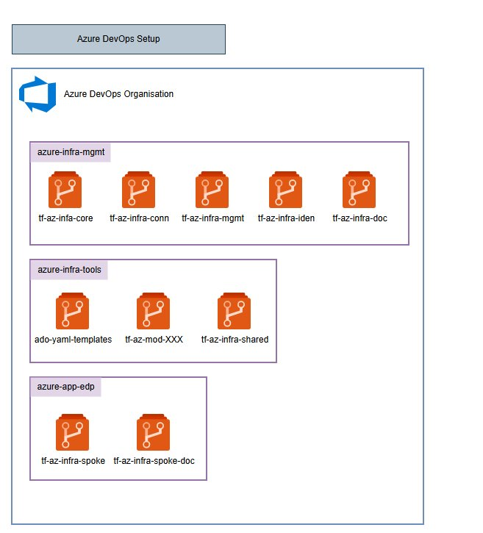
Figure 5- DevOps Organization Structure

There are four primary IaC repositories which contribute to the deployment and maintenance of the Azure Landing Zone. These are captured in the table below.

Repo Name | Description
tf-az-infra-core | This repository hosts Terraform code which defines a list of Azure policies, aligned with Exus’s standards and requirements. These will be deployed to ensure that a baseline set of guardrails is introduced from the outset.  This repository also hosts code for creating the Management Group hierarchy as described in the Management Group design section.
tf-az-infra-mgmt | This repository is responsible for managing Landing Zone management and security services which are used to audit and measure the security posture of the overall solution. The primary services manged in this repo are the centralised Log Analytics workspace for aggregating logs across the platform and Defender for Cloud.
tf-az-infra-conn | This repository is responsible for managing the network services deployed to the Connectivity Subscription including the underlying Virtual Network, Azure Firewall services, private DNS resolver, private Hosted Zones and the VPN Gateway. Given the criticality of these shared networking services, a dedicated repository with strict permissions is warranted.
tf-az-infra-shared | This repository is responsible for managing the Azure services deployed to the Shared Services Subscription. Initially this includes a Virtual Network and a Virtual Machine Scale Set for hosting Azure DevOps private agents.

Continuous Integration / Continuous Delivery (CI/CD)
Version 1 has developed a reusable library of CI/CD pipeline templates aligned to industry best practices for Infrastructure as Code. These templates are designed to streamline and standardise the deployment of Azure resources using Terraform, ensuring consistency, security, and scalability across environments. For Exus, this approach enables automated provisioning and governance of the Azure Landing Zone, supporting both initial and future workloads with minimal manual intervention.
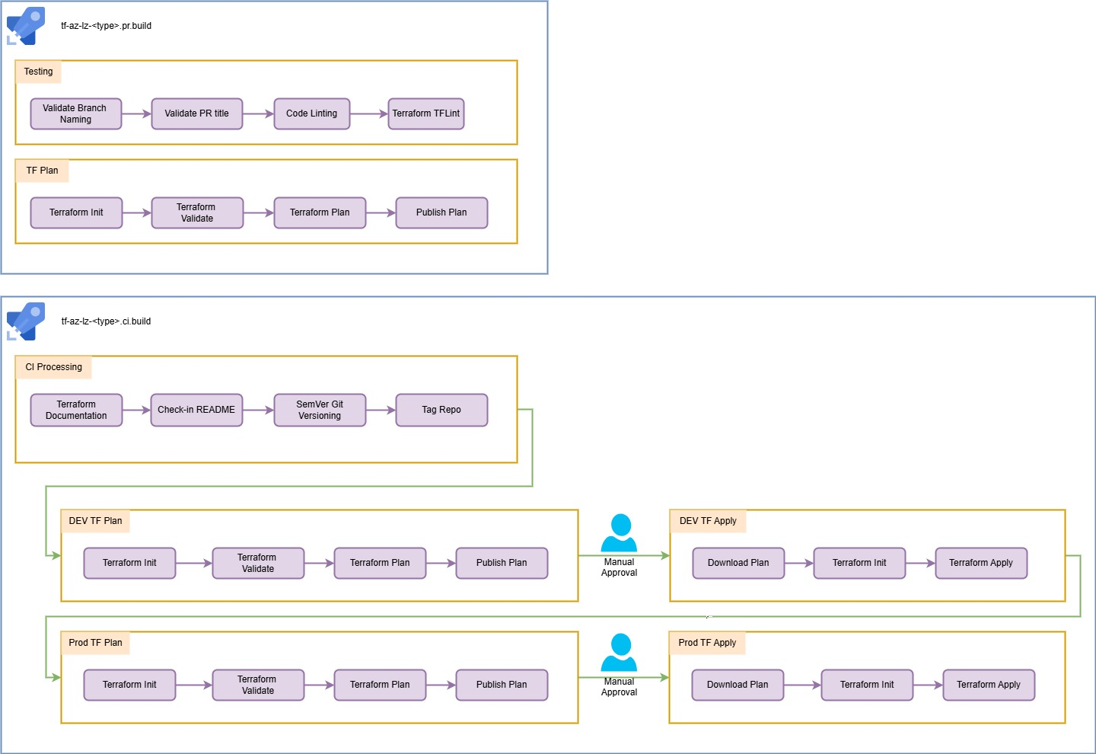
Figure 6 - Infrastructure CI/CD Process
The orchestration process is structured into five key stages: Testing, Planning, CI Processing, Environment Planning, and Environment Deployment. During Testing, all pull requests undergo validation checks including branch integrity, code linting, and Terraform TFLint to ensure quality and compliance. Planning validates proposed changes against the development environment. CI Processing generates documentation and increments repository versions upon merging or manual triggers. Environment Planning creates a Terraform plan for the target environment, and Environment Deployment applies the plan, with approvals required for higher environments. This structured pipeline ensures reliable, traceable, and secure infrastructure deployment across Exus’s Azure estate.

Pricing
This section outlines the indicative costs associated with the Azure services required to establish and operate the Landing Zone. These estimates cover the foundational infrastructure—such as networking, identity, security, and management services—needed to support Exus’s transition to Azure. They do not include costs for workloads hosted within the Landing Zone, such as the Enterprise Data Platform (EDP), which will be scoped separately. All figures are subject to change as the volume of traffic and usage within the Landing Zone evolves over time.

Service​ | Spec​ | Details​ | Monthly Cost​ | Annual Cost​
Azure Firewall​ | Standard​ | Standard tier, 1 Logical firewall units x 1 Month, 100 GB Data processed​ | $914.10​ | $ 10,969.20​
Azure DNS​ | DNS Private Resolver​ | Zone 1, DNS Private Resolver; 1 Inbound endpoints, 0 Outbound endpoints, 0 Rulesets​ | $180.00​ | $ 2,160.00​
Storage Accounts (x12)​ | General Purpose V2​ | Block Blob Storage, General Purpose V2, Flat Namespace, LRS Redundancy, Hot Access Tier, 100 GB Capacity - Pay as you go, 10 x 10,000 Write operations, 10 x 10,000 List and Create Container Operations, 10 x 10,000 Read operations, 1 x 10,000 Other operations. 1,000 GB Data Retrieval, 1,000 GB Data Write, SFTP disabled​ | $37.44​ | $ 449.28​
Azure Private Link (x24)​ | ​ | 24 Endpoints X 1 Month, 100 GB Outbound data processed, 100 GB Inbound data processed​ | $177.20​ | $ 2,126.40​
IP Addresses​ | Basic (Classic)​ | 0 Dynamic IP Addresses X 1 Month, 1 Static IP Addresses X 1 Month​ | $2.63​ | $ 31.56​
VPN Gateway​ | VpnGw2AZ tier​ | VPN Gateways, 730 gateway hour(s), 0 additional S2S tunnels (beyond included amount), 0 additional P2S connections (beyond included amount), 0 GB, Inter-VNET VPN gateway type​ | $394.20​ | $ 4,730.40​
Virtual Machine Scale Sets​ | D2s v3 (2 vCPUs, 8 GB RAM​ | 1 Month (Pay as you go), Linux, (Pay as you go)​ | $70.08​ | $ 840.96​
Azure NAT Gateway​ | Standard​ | NAT Gateway created with 1 Month and 100 GB of data processed​ | $37.35​ | $ 448.20​
Microsoft Defender for Cloud​ | Standard​ | Microsoft Defender for Cloud Security Posture Management: 20 Billable Resources x 1 Month​ | $102.20​ | $ 1,226.40​
Azure DevOps​ | ​ | 5 Basic Plan license additional users, 0 Basic + Test Plans license users, Free tier - 1 Microsoft Hosted Pipeline(s), 2 Self Hosted Pipeline(s), 0 GB Artifacts, GitHub Advanced security - 0 committers covered by code security and 0 committers covered by secrets protection​ | $45.00​ | $ 540.00​
Total​ |  |  | $1,960.20​ | $ 23,522.40​


For more information,
please visit version1.com
Thank you

